Exercises 2
Relationships between events illustrated.

Two screening test are available for identifying loan defaulters. These tests are used to evaluate requests for new loans.

Test A – Credit rating result: good (G) or poor (P)

Test B - Employment Status result : satisfactory (S) or not satisfactory (NS)

Statistical analysis has provided the following estimates of the test performances produced the following tables:

Sample size = 10158 loans

Default = D, non default = 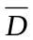

 |  | Test A
 |  | D
 | P | 135 | 1008
 | G | 255 | 8760

 |  | Test B
 |  | D
 | NS | 120 | 444
 | S | 270 | 9324

We shall estimate the probabilities from this large sample.

Dividing the cells of A by the sample size we get the following probabilities:

 |  | Test A
 |  | D
 | P | 0.01329 | 0.099232
 | G | 0.025103 | 0.862374

What we have in the table is that:

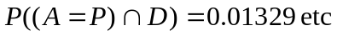

or nearly 4% of loans default.

Accuracy of the test at picking up potential defaulters is described by:
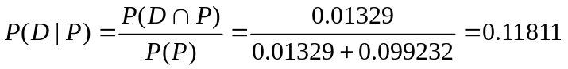

Thus 12% of people with poor credit rating default, in 88% of these cases the loan is OK.

Suppose the evaluating software applies this criterion rejecting those with the result P.

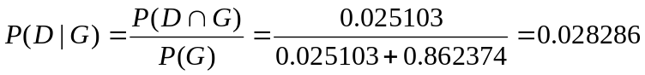

A reduction in the bad credit rate from 3.8% to 2.8%. However customers will be lost:

, 11.3% of customers are rejected.

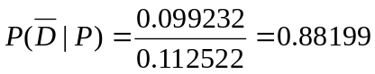 , 88.2% of these would have been OK.

Suppose an OK loan nets the company $2000, the loss on a defaulted loan is $10000.

If they don’t use the criterion they will make on (large) N loan applications:

N * (0.038393* (-10000) + 0.961607*2000)=1539.279*N

If they do then

N*0.887478*(0.028286*(-10000)+0.971714*2000)=1473.715*N

So they should leave well alone or get better info they are rejecting too many.

Exercises:

As exercise evaluate Test B in the same way.

If you could only use one test which would you use?

Using both the tests.

We now have 3 events (P,G), (S,NS) and (D,)

The two tables above do not (in general) contain enough information for the 3 event model. What is the relationship between the tests?

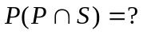
How do the tests jointly impact on P(D) ?

The full model involves 7 parameters; suppose the disaggregated table is :

 |  | Defaulting
Test A | Test B | D
 | NS | 108 | 432
P
 | S | 27 | 576
 | NS | 12 | 12
G
 | S | 243 | 8748

Note: the data in this table is the disaggregated version of the data in the tables above.

So that 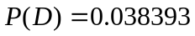 is the same as before.

We can get the probabilities as:
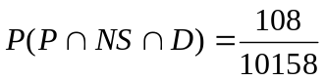 etc.

Exercises:
Compute the probabilities of defaulting and of rejecting a potentially good client with the following strategies:

- Only grant a loan if pass both tests.
- Only reject if fail both tests .

Are the tests independent?

